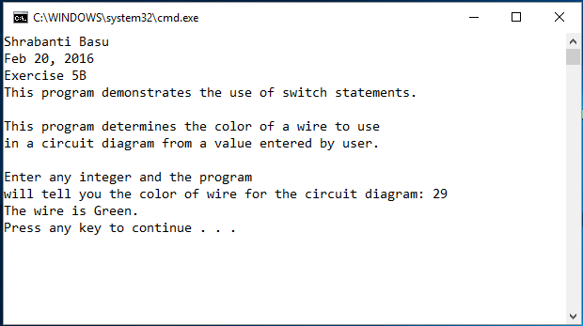

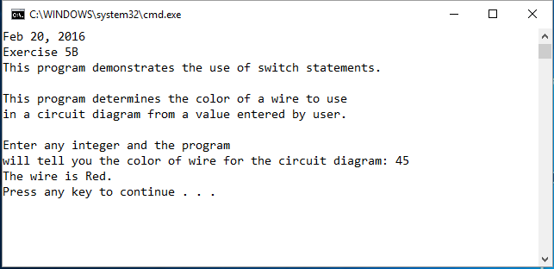

//Shrabanti Basu

//Feb 20, 2016

//Exercise 5B

//This program demonstrates the use of else-if else conditions.

#include <iostream>

using namespace std;

int main()

{

cout << "Shrabanti Basu\n";

cout << "Feb 20, 2016\n";

cout << "Exercise 5B\n";

cout << "This program demonstrates the use of switch statements.\n\n";

cout << "This program determines the color of a wire to use\n"

<< "in a circuit diagram from a value entered by user.\n\n";

int number = 0; //to store the user entered integer value

char choice; //determine the case for the switch statement

/\*

The program lets the user enter an integer value and checks for a case and displays appropriate message.

This program could have been written with just menus, but that way the user could not enter the values 29 and

45 explicitly. So I let the user enter values, then check for cases in switch statement.

Also, checking for many integer values 1, 2, ... does not seem logical where there is a huge range.

So this is the best way for the user to enter a number and also use the switch statement at the same time.

Though some compilers may support the use of a range in case statements, this compiler does not.

\*/

cout << "Enter any integer and the program\n";

cout << "will tell you the color of wire for the circuit diagram: ";

cin >> number;

//determine the case from the user entered input

if (number < 10)

choice = 'A';

else if (number < 30)

choice = 'B';

else if (number < 40)

choice = 'C';

else

choice = 'D';

//check for cases and print appropriate message

switch (choice)

{

case 'A':

cout << "The wire is White.\n";

break;

case 'B':

cout << "The wire is Green.\n";

break;

case 'C':

cout << "The wire is Blue.\n";

break;

case 'D':

cout << "The wire is Red.\n";

break;

default:

cout << "Invalid Input.\n";

}

return 0;

}